Building A Bad Robot

Jochen Alt



Most important thing of a robot is to look good. The actuators should have human-like proportions, movements should be smooth, and – rather a matter of personal taste – I do not like humps or bulges with motors or gearboxes. All stuff should be inside the regular housing.

After checking lots of the stuff around on youtube, I recognized that just a few DIY robots are close to what I had in mind:

Andreas Hölldorfer   
(<https://hackaday.io/project/3800-3d-printable-robot-arm>)

Andreas created an interesting design with belt drives, stepper motors, and encoders. I got lots of ideas from his construction, and some of my parts are derived directly from his models.



Ángel Larrañaga Muro  
(<https://hackaday.io/project/12989-thor>)

He used an interesting differential gearbox for the lower actuators.

These two have a professional design, while most of the robot arms on youtube are servo based and more or less constructed the same. Their biggest weakness is inner instability and - as a result – imprecise movements.

I like spheres, in the beginning I wanted all joints shaped like a ball accepting that this will cause trouble when it comes to space. There should be not too much cables and stuff hanging everywhere, and all actuators should look similar. This is what I had in mind:



Figure 1‑1 Design Sketch

Unfortunately, this made the joints really big, the picture does not really reflect this. I gave up the spheres, and went on with cylinders, which made the appearance slimmer.

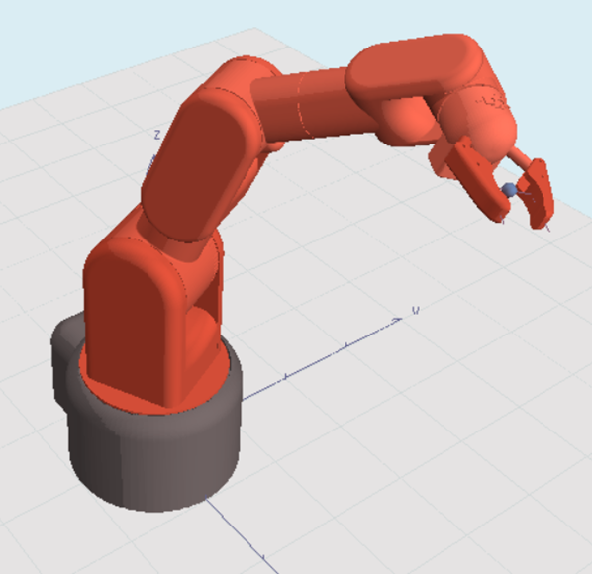

Stepper or Servos, Gears or Belt Drives

Most of the DIY robots are using servos, mostly for convenience, since the encoder is built-in already and they are easy to control. Thing is, when it comes to higher torque, the connection of the servo with the actuator becomes difficult, and hard to make of 3D printed material. If the servo or the flange moves just a little bit within the housing, the according play will magnify to a significant amount at the end of the actuator. The required precision to avoid this is way above hobby grade components. I guess this is why I never saw a robot with servos which movements were not bumpy.

And servos are boringly easy to use. No fun in construction. A motor with a belt drive and a separate angle sensor solves this, it provides low backlash and allows the electronics to compensate imprecise parts with the sensor placed separately from the motor. Additionally, the motor of an actuator can be placed in the previous joint, lowering the centre of gravity of each actuator.

When a belt drive is set, choice comes naturally to stepper motors, since an additional gearbox is not necessary anymore, torque is high and the belts should compensate the vibrations coming from the stepping nature of these motors.

Construction

Inverse kinematics, i.e. computation of joint angles out of the gripper’s position can be hard. If the design is too playful, nearly impossible complex. So, it is a good idea to ease the maths by having the upper three axes joining in one point. Later in chapter 6 we will see that with that limitation kinematics becomes possible without having a mathematician at hand (still not easy, but feasible)

But, lets start with the gripper

## Gripper

Due to space limitations, it seems to be appropriate to use a servo for the gripper. I used a gripper standard principle and a HerkuleX Robot Servo with 0,12 Nm:

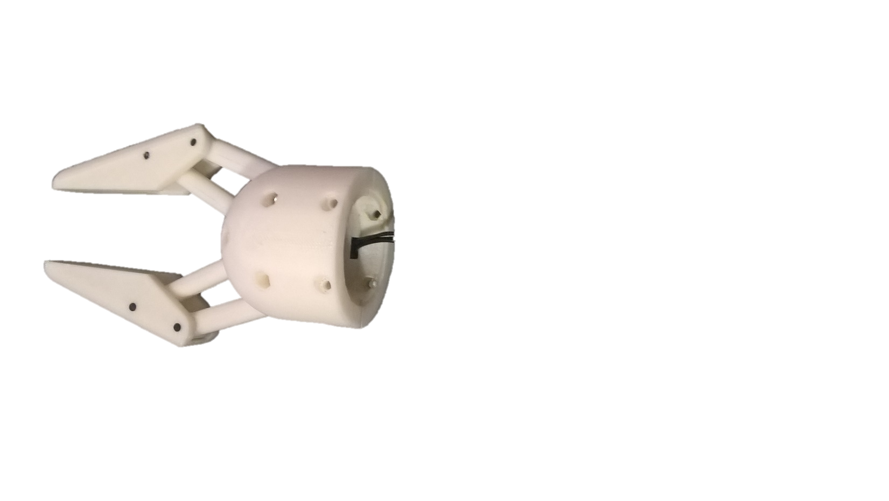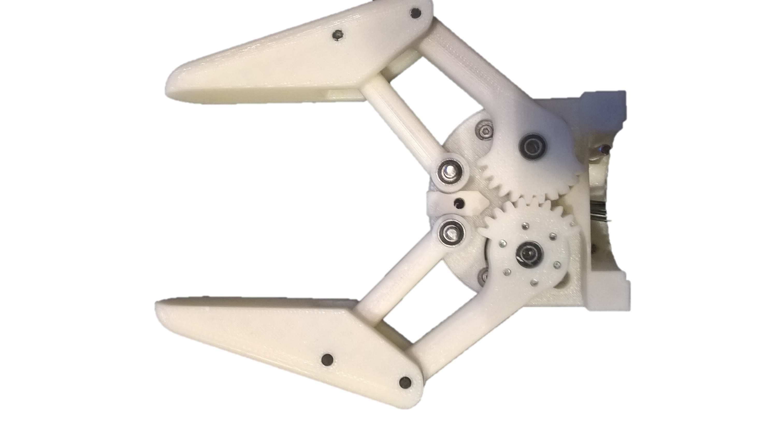 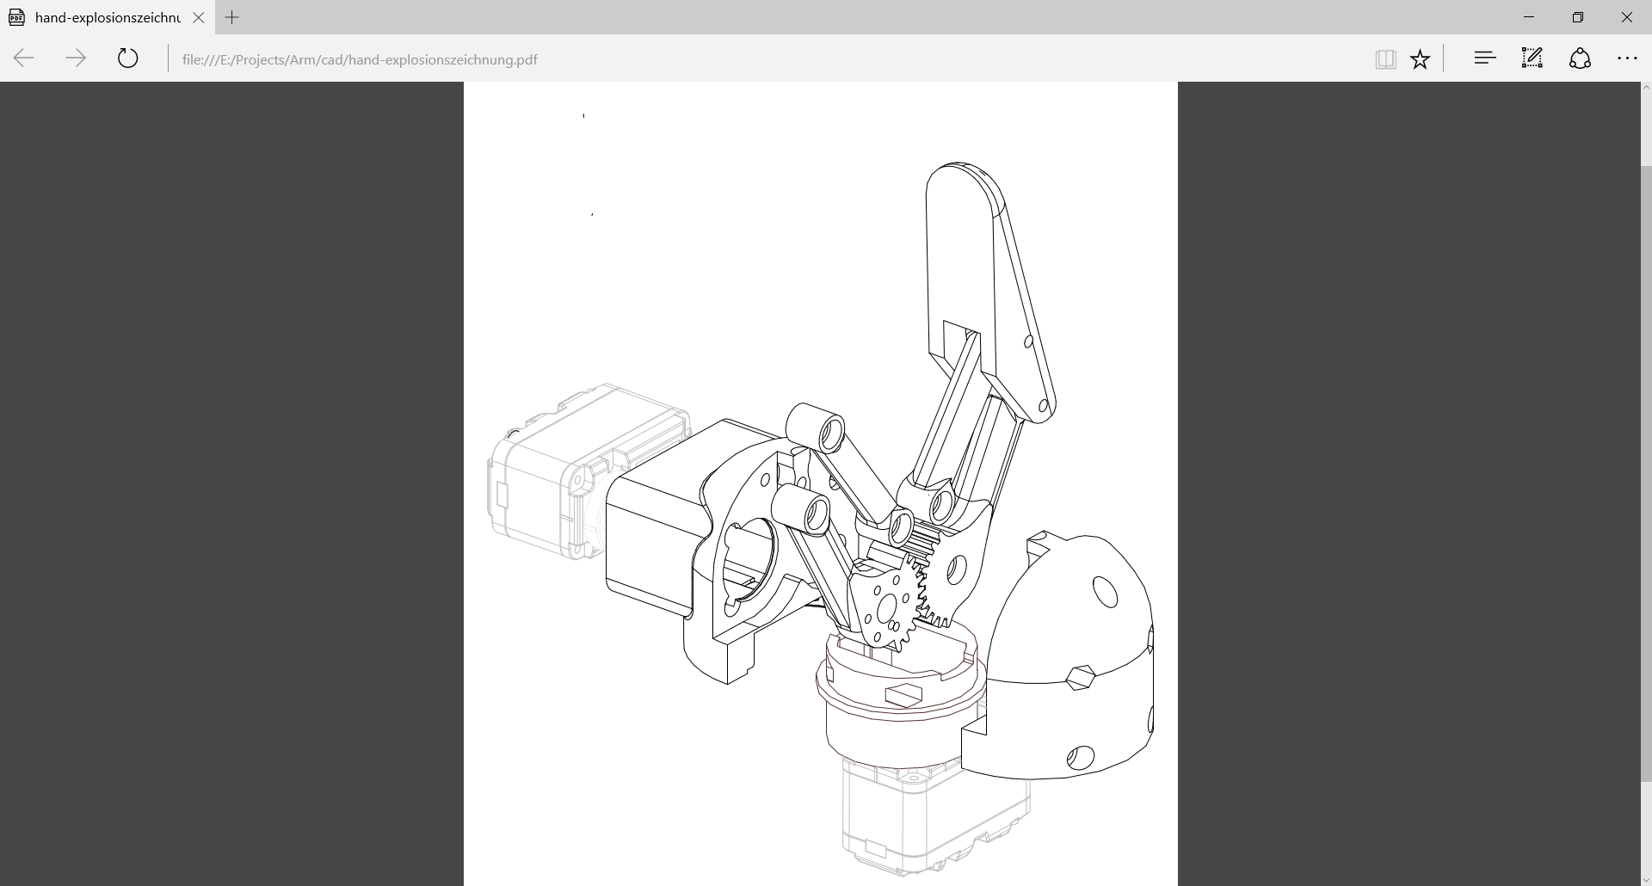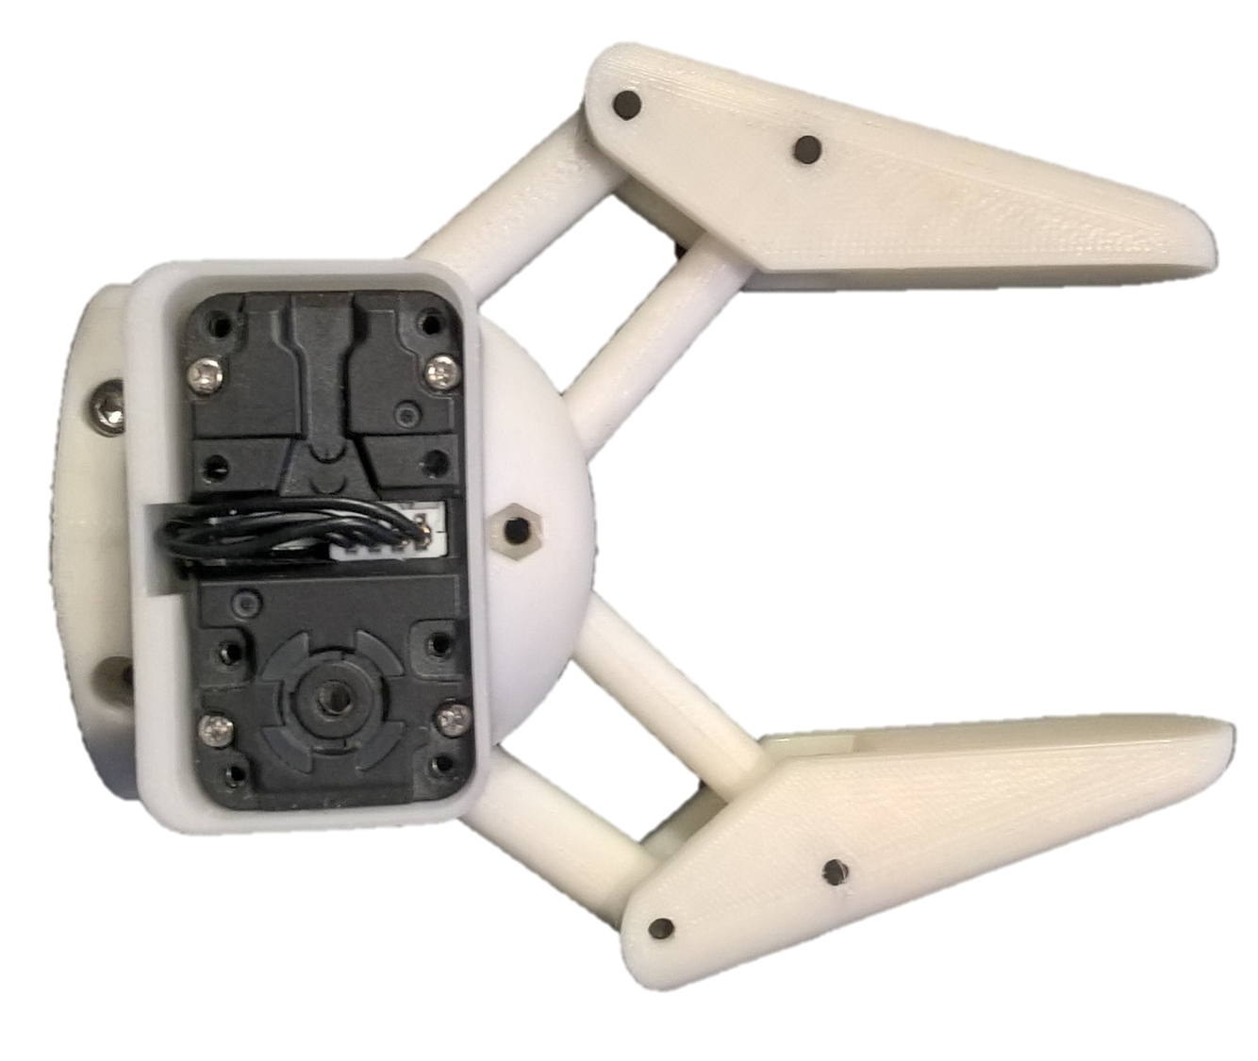

The base and its magnetic angle sensor is shown here. The according magnet will be mounted right above the ic on the sensor breakout:

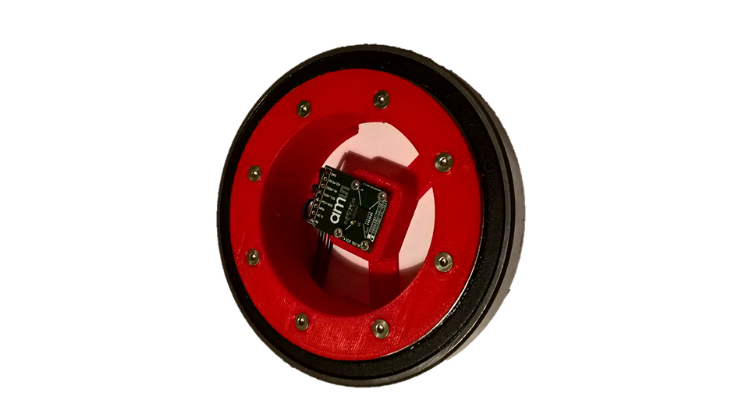

Figure 2‑1 Hip ball bearing with sensor

The outer side of the ball bearing is mounted on a belt pulley. Since all cables of the robot will come down to the base, we need a cable protection preventing that the sensor and its magnet is disturbed by all the cables. The cable protection is the small circle in the middle.

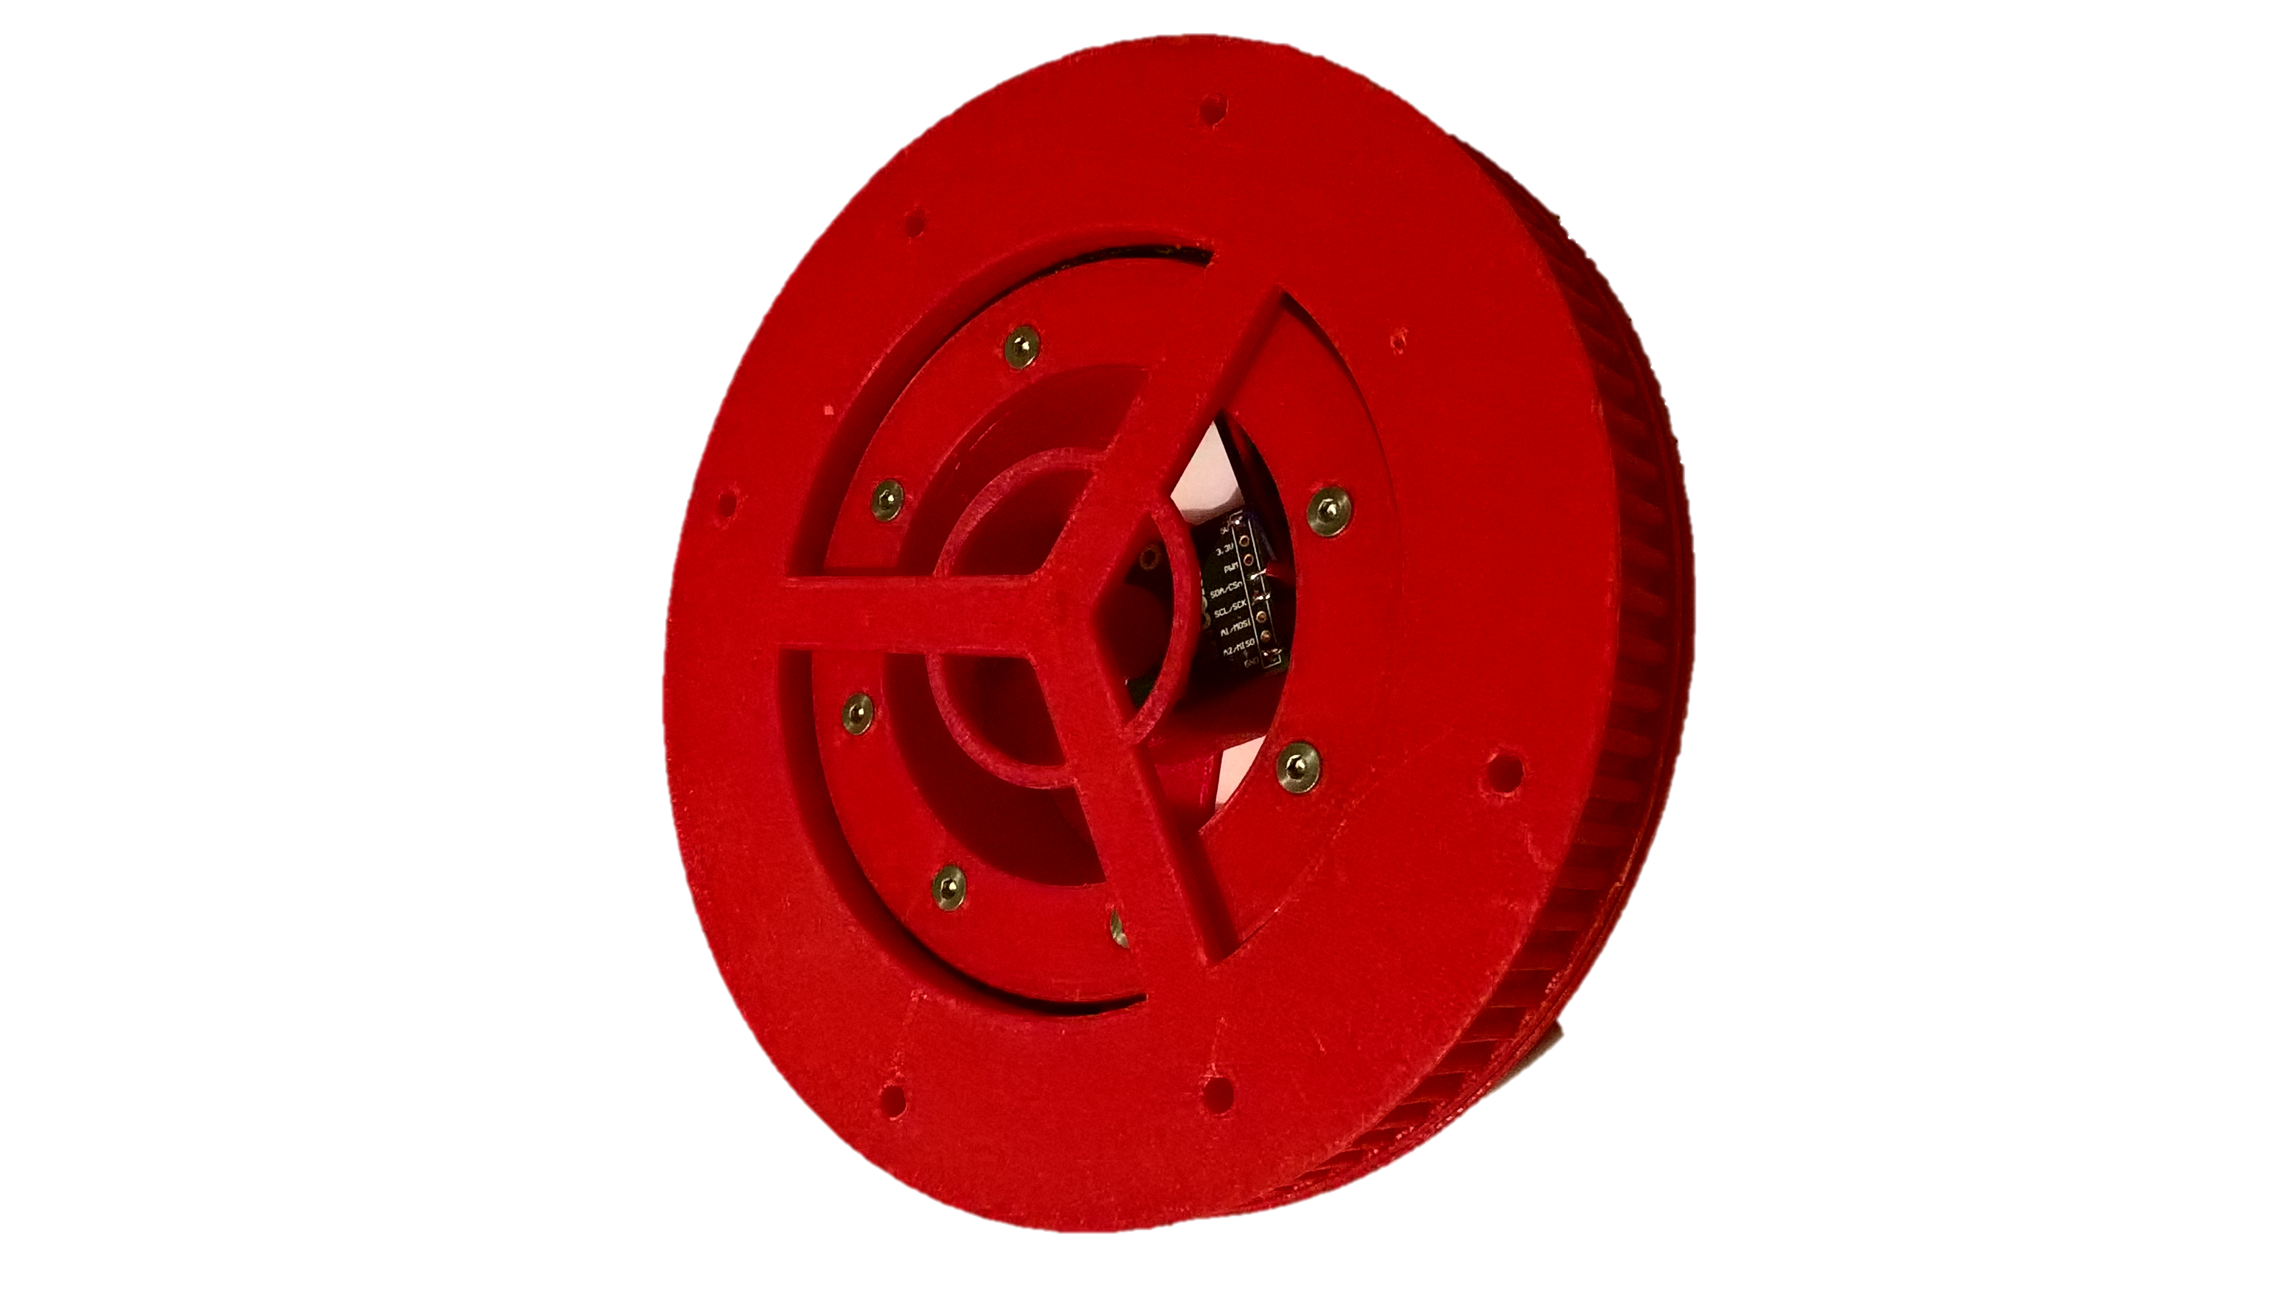

Figure 2‑2 Hip's belt pulley

On top of the belt pulley, a big cylinder will hold the biggest motor driving the shoulder. The motor compartment can be seen above the cable protection:

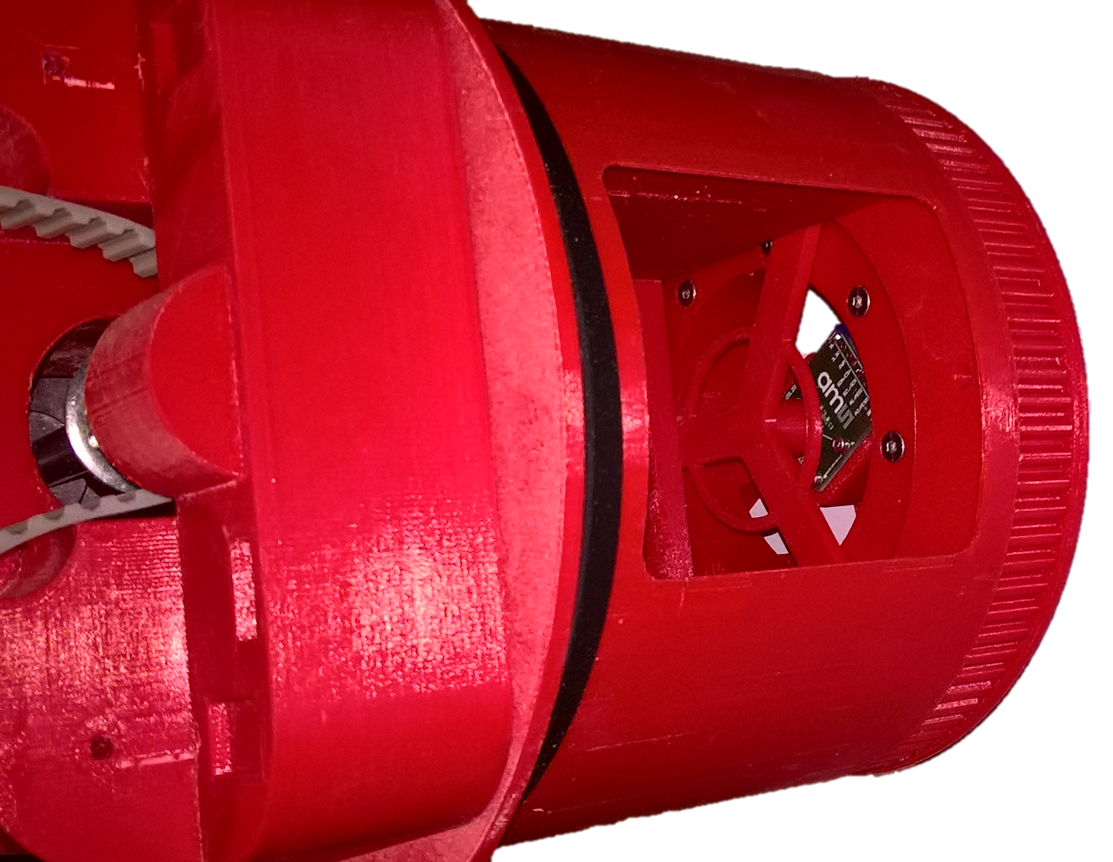

Figure 2‑3 Motor compartment of shoulder

The complete base is shown here including the hip motor and the pulley:

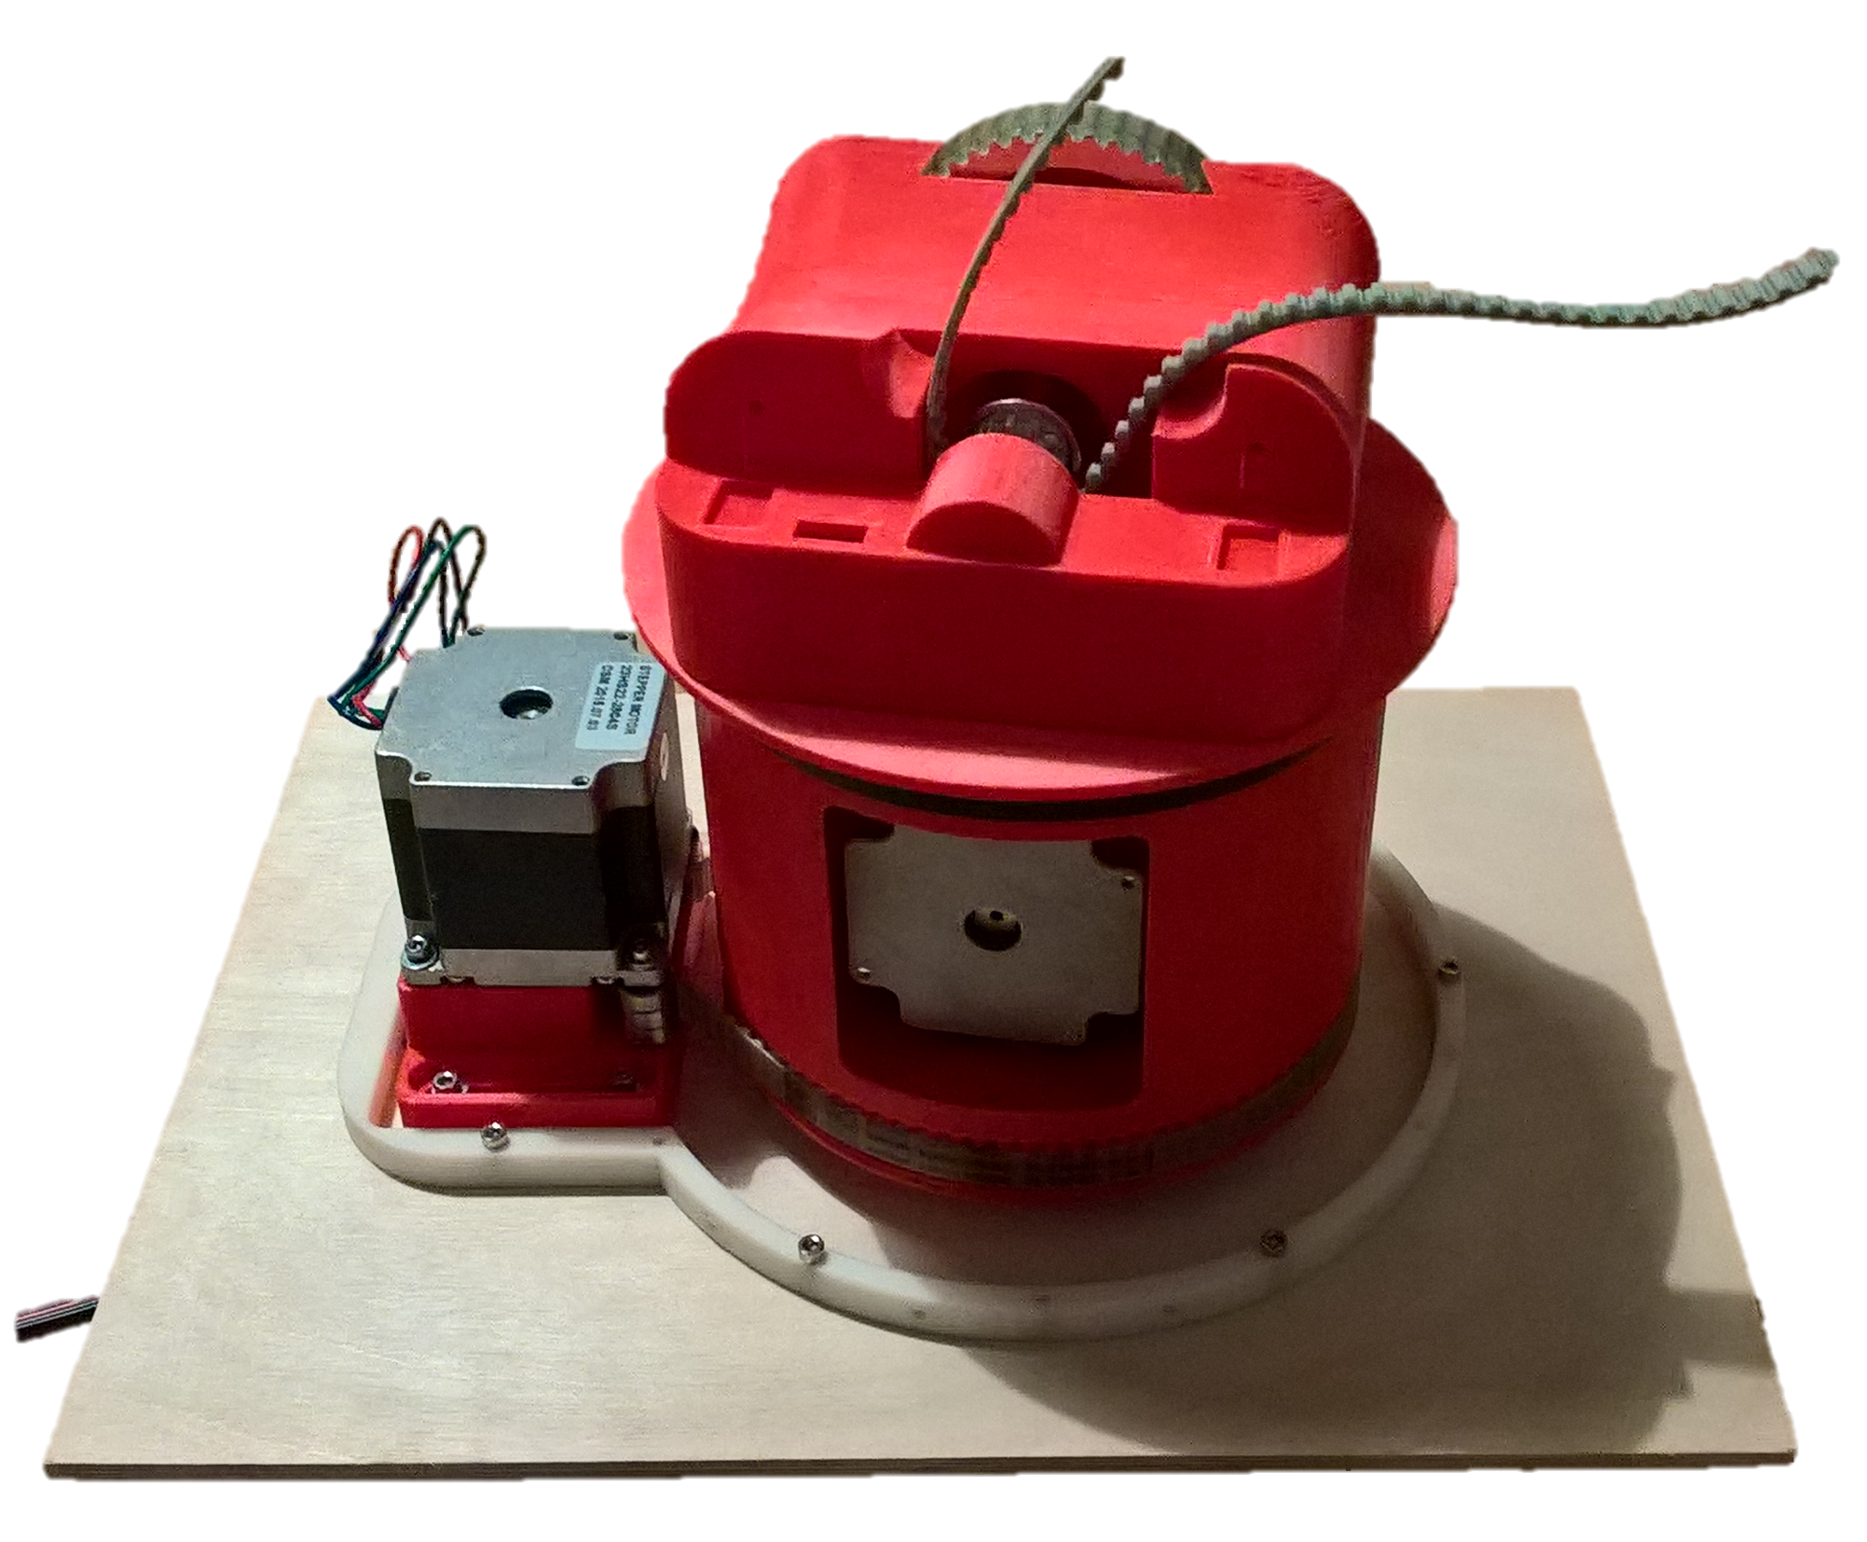

Figure 2‑4 Base on wodden platform

On top of the base, a countershaft with two belt discs provide the necessary gear reduction of 1:20 reducing the required torque of 10Nm.

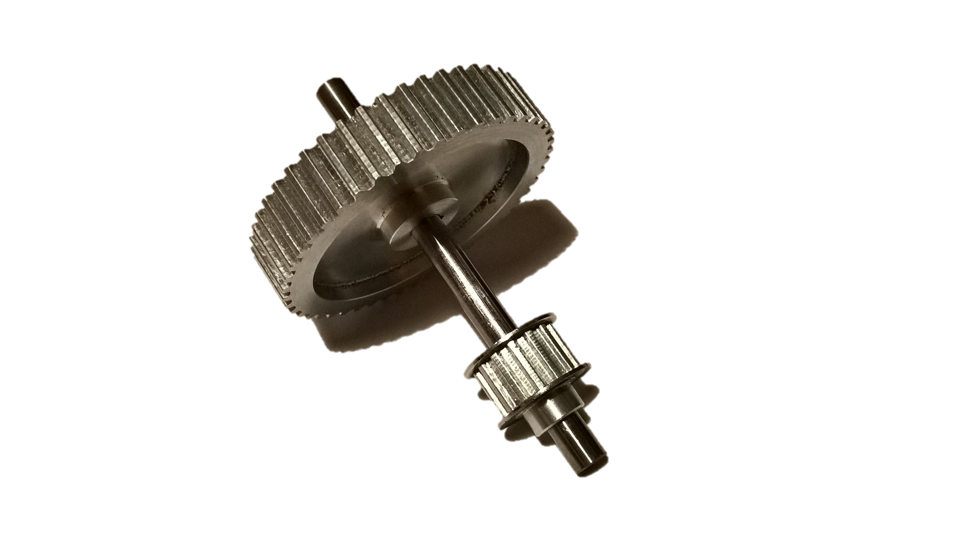

Figure 2‑5 Countershaft of shoulder

With a torque like that, a proper shaft-to-collar connection is necessary.

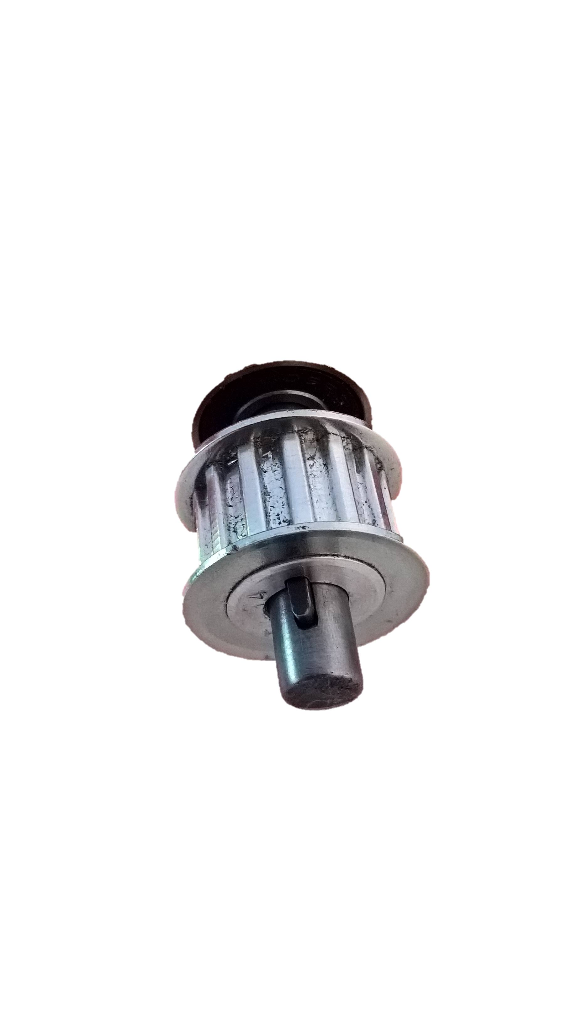I use a feather key for those heavy-load connections, although it requires a lot of filing to make the notch in the belt pulley. The notch in the joint is easily done with a milling machine. Connections in the higher actuators with no big load are done with simple grub screws

Architecture

In general, the information flow looks like this:

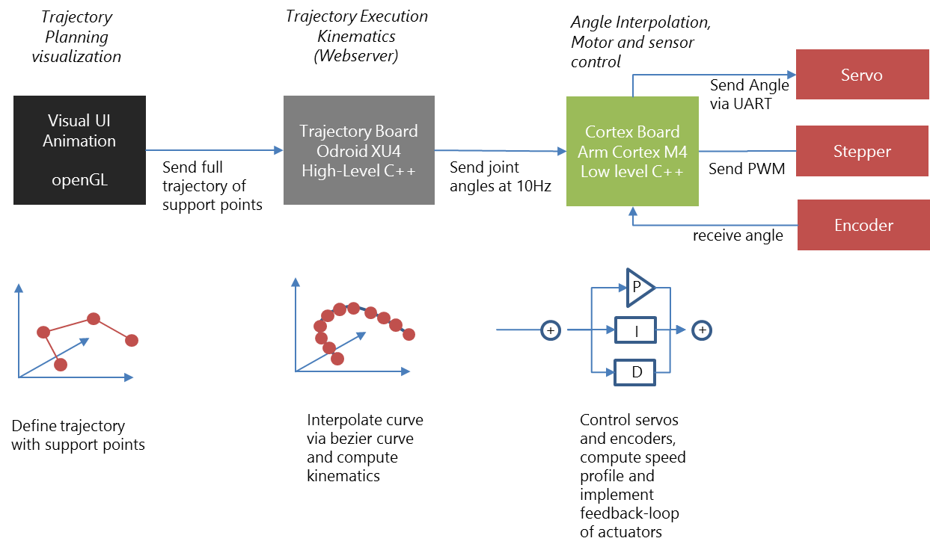

The visualizer is mainly the UI-based tool to plan trajectories by defining singular points. These points are sent to the Trajectory Execution, where the trajectory is interpolated using Bézier curves. Out of each point of the interpolated curve the angles are computed and send to the controller board, where a PID controller takes care that each actuator actually follows the curve.

On the mechanical side, we have two actuators driven by a servo (mainly due to space restrictions) and four actuators driven by a stepper/rotary encoder combination.

The servos are controlled directly by the cortex controller board via a serial interface. The steppers do not have an internal feedback loop, so we need rotary encoders detecting the absolute angle of the joint and allowing to implement feedback controllers. Depending on the actuator, the steppers provide a torque between 26Ncm (elbow) and 3,1Nm (upperarm). For space reasons, the gripper and the wrist is driven by a servo.

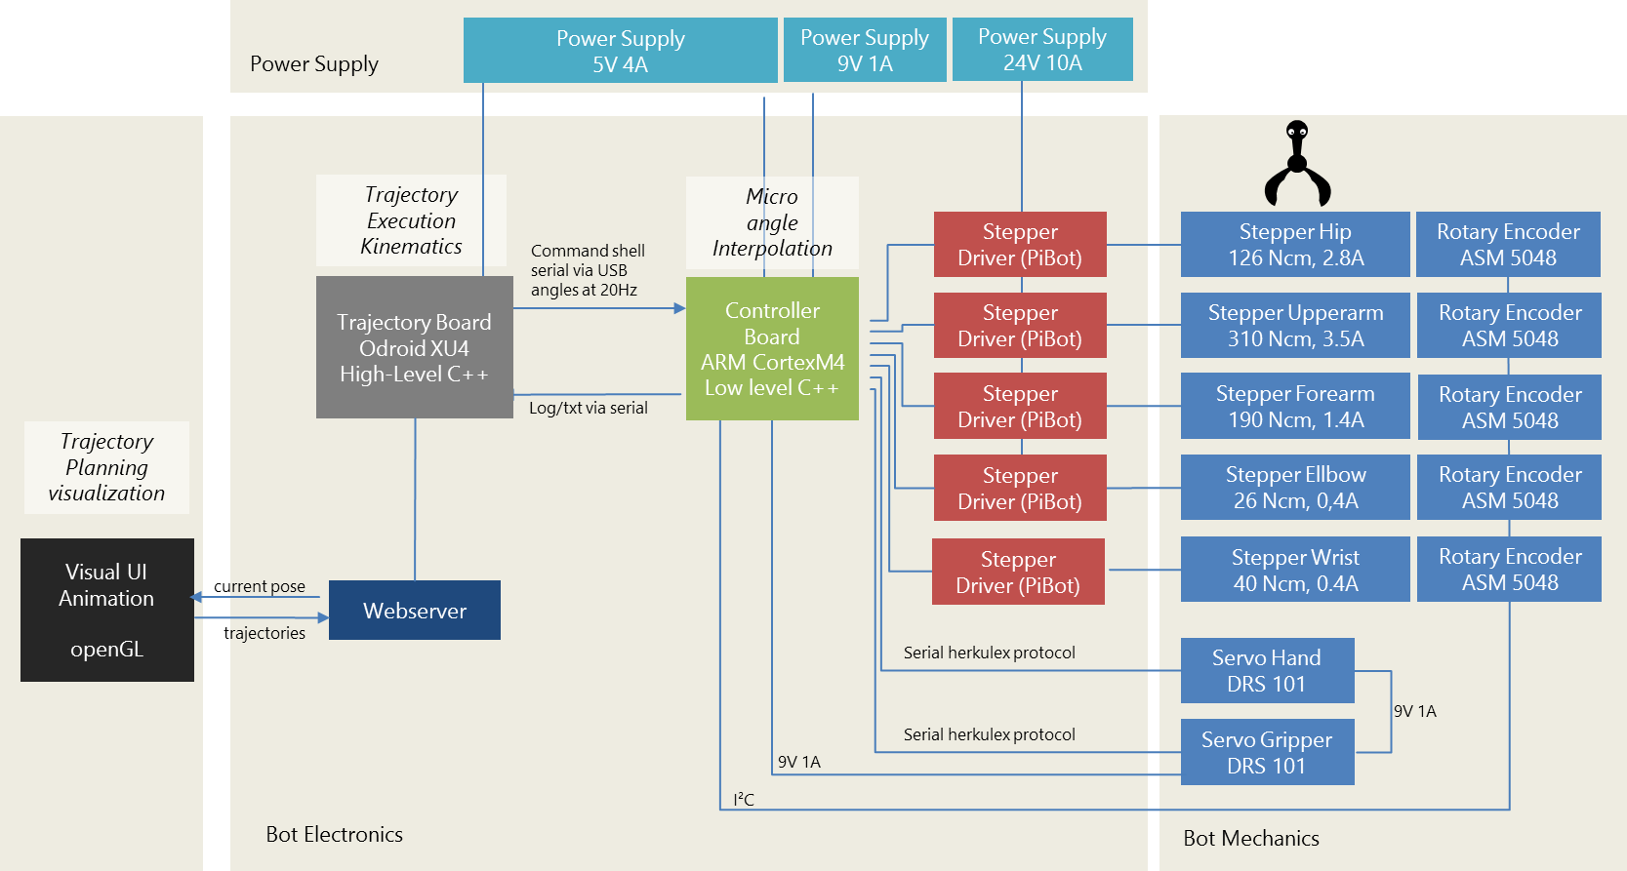

Figure 3‑1 Architecture

The steppers are driven by retail stepper drivers (PiBot Stepper Driver) around the popular PWM stepper driver Toshiba 6600 (4.5A max). The stepper drivers are directly connected to the Controller Board. It receives joint angles at 20Hz, interpolates the points in between, and sends the according PWM signal to the stepper drivers and to the servos. Besides micro interpolation of the trajectory, the controller board takes care of the speed profile, i.e. it limits the acceleration and speed of each actuator. The controller board is a DIY board around an ARM Cortex M4 with 120 MHz (Teensy 3.5). I started with an ATmega 644 8-bit controller, but it turned out that the ATmega was not able to control 5 steppers with a proper sample rate, let alone reading 5 encoders on top.

The controller board is fed by the trajectory board, which is an Odroid XU4 board with a 2GHz octa core.

The trajectory controller board is encapsulated by a webserver exposing the current movement and accepting commands like new trajectories.

Trajectories

Planning a trajectory means defining a sequence of poses in 3D space. These defined poses are interpolated in order to result in a smooth and continuous curve. Most beautiful are cubic Bézier curves.

Bézier curves are polynoms of 3rd grade using a start and an end point and two support points defining the curvature at the start and end point. The trajectory is defined by the start and the end point, the support point is not on the trajectory but used to make it smooth only. The computation is based on a parameter *t=0..1* defining the ratio of how much the current position has already made of the full curve. Let’s assume, we have the four points P0..P3, of which P1 and P2 are support points the curve does not touch.

|  |  |
| --- | --- |
| $C_{bezier}\left(t\right)= \sum_{0}^{3}{\left(\begin{matrix}3 \\ i\end{matrix}\right)t^{i}{\left(1-t\right)}^{3-i}P_{i}}= {{\left(1-t\right)}^{3}P}_{0}+3{t{\left(1-t\right)}^{2}P}_{1}+3{t^{2}\left(1-t\right)P}_{1}+ {t^{3}P}_{3}$ | (4‑1) |

This computation is done for x, y, and z coordinates. Normally being beautiful, but Bézier curves have a tendency to “bounce”, if the support points P1 and P2 differ too much in terms of the distance to the trajectory points P0 and P3. So, it is necessary to normalize support points by a small trick:

The picture illustrates a trajectory defined by A, B, C, and D. We want to model the piece between B and C with a cubic Bézier curve.

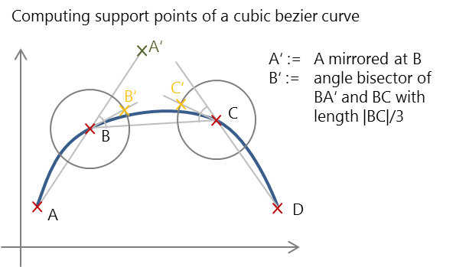The support point B’ is computed by taking point A, mirroring it at B (A’), and moving along the angle bisector of A’ B C by a 3rd of the length of BC, C’ is computed in an analogous manner.

This approach is rather arbitrary, but results in a smooth and non-oscillating curve.

Now the curve looks fine, but simply following that curve is not enough to make a smooth movement. We need a speed profile that avoids jerky movements.

Speed Profiles

Purpose of speed profiles is to avoid jerky movements by having a smooth acceleration and decelaration. The classical approach is to use trapezoidal speed profiles like this:



Figure 5‑1 trapezoid speed profile

This trapezoid speed profile results in a constant (maximum) acceleration, then continuing with no acceleration, and a constant deceleration until zero speed is reached. To get the position on a curve, speed is integrated resulting in a diagram like this:



Figure 5‑2 position diagram with trapezoid speed profile

Despite of the corners in the speed profile, the position profile looks smooth. Still, how is a profile like that computed? Having a constant acceleration *a*, start speed vstart, an end speed vend, the distance *d* (length of the Bezier curve) and the desired duration of the complete profile tg, we need to compute the time t0 and t1 which is the duration of the starting acceleration and final deceleration. The full distance is given by

|  |  |
| --- | --- |
| $$d=v_{start}t_{0}+\frac{1}{2}a {\left(t_{0}\right)}^{2}+v_{middle}t_{middle}+ v_{end}t_{1}+\frac{1}{2}a {\left(t_{1}\right)}^{2}$$ | (5‑1) |

The duration and speed of the plateau is given by

|  |  |
| --- | --- |
| $v_{middle}=v_{start}+at_{0}= v_{end}+at_{1}$ | (5‑2) |
| $t_{middle}=t_{g}-t_{0}-t_{1}$ | (5‑3) |

Rearranging these equations to get $t_{0}$ ends up in

|  |  |
| --- | --- |
| $d=v_{start}g t_{g}+\frac{1}{2}a {\left(u\right)}^{2}+ t_{0}a(t_{g}-u)+ {t_{0}}^{2}\left(a\right)$ | (5‑4) |

with

|  |  |
| --- | --- |
| $u=\frac{\left(v_{start}- v_{end}\right)}{a}$ | (5‑5) |

Finally, we get

|  |  |
| --- | --- |
| $t_{0}=\frac{-(a\left(t_{g}-u\right)± \sqrt{{\left(a(t_{g}-u)\right)}^{2}-4a\left(v_{start}g t_{g} + \frac{1}{2}a {\left(u\right)}^{2}\right)}}{a}$ | (5‑6) |

With (5‑2) we get tg.

This holds true for a trapezoid profile only, since to model a full trajectory that consist of single movements we also need profiles that represent a ramp or stairways, depending on the constrains in terms of duration, distance, and start/end speed. This ended up in quite a lot of code treating all the different cases

Having a nice trajectory with a smooth speed profile, we need to convert the absolute coordinates into angles of the joints. This is done by inverse kinematics described in the following chapter.

Kinematics

Kinematics is about computation of the tool-centre-point (TCP) out of joint angles and vice versa. First is simple, latter more tricky. But before starting any kinematics, it is necessary to define all coordinate systems.



Figure 6‑1 Coordinate Systems in default position

The most important design decision is to let the three upper axis’ intersect in one point, the so-call wrist-center-point (WCP). This decision makes the computation of the inverse kinematic solvable without numeric approaches.

The picture shows the used coordinate systems in the default position of the bot, having all angles at 0°, starting from the base (angle0) and ending with the coordinate system of the hand (angle6). For convenience the forearm (angle1) adds +90° to the real angle in order to have the base position at 0°of the bot, although the illustrated actually is -90°. The coordinate systems have been are arranged according to the Denavit Hardenberg convention, which is:

* The transformation from anglei to anglei+1 is given via

1. rotating around the x-axis by 
2. translation along the x-axis by *a*
3. translation along the z-axis by *d*, and
4. rotation around the z-axis by joint angle $θ$

So, the Denavit Hardenberg parameters are:

|  |  |  |  |
| --- | --- | --- | --- |
| Joint | a[°] | a[mm] | d[mm] |
| hip | -90° | 0 | d0 |
| upperarm | 0 | a1 | 0 |
| forearm | -90° | 0 | 0 |
| ellbow | 90° | 0 | d3 |
| wrist | -90° | 0 | 0 |
| hand | 0 | 0 | d5 |

Table 6‑1 Denavit Hardenberg parameters

The general definition of a Denavit Hardenberg (*DH*) transformation is

|  |  |
| --- | --- |
| $$T=\left(\begin{matrix}\cos{θ} & -\sin{θ} & \sin{θ}\sin{α} & a \cos{θ} \\ \sin{θ} & \cos{θ} & -\cos{θ}\sin{α} & a \sin{θ} \\ 0 & \sin{α} & \cos{α} & d \\ 0 & 0 & 0 & 1\end{matrix}\right)$$ | (6‑1) |

which is a homogeneous matrix with two rotations (x,z) and two translations (x,z).

Combined with the DH parameters, the following DH matrixes define the transformation from one joint to its successor:

|  |  |
| --- | --- |
| $$T_{0}^{1}=\left(\begin{matrix}\cos{θ_{0}} & 0 & \sin{θ_{0}} & 0 \\ \sin{θ_{0}} & 0 & -\cos{θ_{0}} & 0 \\ 0 & -1 & 0 & d_{0} \\ 0 & 0 & 0 & 1\end{matrix}\right)$$ | (6‑2) |
| $$T_{1}^{2}=\left(\begin{matrix}\cos{θ_{1}} & -\sin{θ_{1}} & 0 & a_{1} \cos{θ_{1}} \\ \sin{θ_{1}} & \cos{θ_{1}} & 0 & a_{1} \sin{θ_{1}} \\ 0 & 1 & 0 & 0 \\ 0 & 0 & 0 & 1\end{matrix}\right)$$ | (6‑3) |
| $$T_{2}^{3}=\left(\begin{matrix}\cos{θ_{2}} & 0 & \sin{θ_{2}} & 0 \\ \sin{θ_{2}} & 0 & -cos{θ_{2}} & 0 \\ 0 & -1 & 0 & 0 \\ 0 & 0 & 0 & 1\end{matrix}\right)$$ | (6‑4) |
| $$T_{3}^{4}=\left(\begin{matrix}\cos{θ_{3}} & 0 & \sin{θ_{3}} & 0 \\ \sin{θ_{3}} & 0 & -cos{θ_{3}} & 0 \\ 0 & 1 & 0 & d_{3} \\ 0 & 0 & 0 & 1\end{matrix}\right)$$ | (6‑5) |
| $$T_{4}^{5}=\left(\begin{matrix}\cos{θ_{4}} & 0 & \sin{θ_{4}} & 0 \\ \sin{θ_{4}} & 0 & -cos{θ_{4}} & 0 \\ 0 & -1 & 0 & 0 \\ 0 & 0 & 0 & 1\end{matrix}\right)$$ | (6‑6) |
| $$T_{5}^{6}=\left(\begin{matrix}\cos{θ_{5}} & -\sin{θ_{5}} & 0 & 0 \\ \sin{θ_{5}} & \cos{θ_{5}} & 0 & 0 \\ 0 & 0 & 1 & d_{5} \\ 0 & 0 & 0 & 1\end{matrix}\right)$$ | (6‑7) |

Forward Kinematics

With the DH transformation matrixes at hand, computation of the bot’s pose out of the joint angles is straight forward. The matrix representing the gripper’s pose $T_{0}^{6}$ is

|  |  |
| --- | --- |
| $$T_{0}^{6}= T_{0}^{1} T_{1}^{2}{ T}_{2}^{3}T_{3}^{4}T_{4}^{5}T_{5}^{6}$$ | (6‑8 |

By multiplying the transformation matrix with the origin (as homogeneous vector), we get the absolute coordinates of the tool centre point in world coordinate system (i.e. relative to the bot’s base).

|  |  |
| --- | --- |
| $$TCP= \left(\begin{aligned}\begin{matrix}0 \\ 0 \\ 0\end{matrix} \\ 1\end{aligned}\right)T_{0}^{6}$$ | (6‑9) |

The orientation in terms of roll/nick/yaw of the tool centre point can be derived out of $T_{0}^{6}$ by taking the part representing the rotation matrix (). [1]

|  |  |
| --- | --- |
|  | (6‑10) |
|  | (6‑11) |
| $$nick = β=atan2({{-R}_{0}^{6}}_{31},\sqrt{{{R_{0}^{6}}_{21}}^{2}+ {{R_{0}^{6}}_{21}}^{2}})$$ | (6‑12) |
| $$roll = γ=atan2({R_{0}^{6}}_{32},{R_{0}^{6}}_{33})$$ | (6‑13) |

Due to singularities, we need to consider $β=\frac{π}{2}$ and use

|  |  |
| --- | --- |
| $$α=0$$ | (6‑14) |
| $$γ=atan2({R_{0}^{6}}_{12},{R_{0}^{6}}_{22})$$ | (6‑15) |

instead. if $β=-\frac{π}{2}$

|  |  |
| --- | --- |
| $$α=0$$ | (6‑16) |
| $$γ=-atan2({R_{0}^{6}}_{12},{R_{0}^{6}}_{22})$$ | (6‑17) |

**Note:** Unfortunately, the gripper’s coordinate system is not appropriate for human interaction, since the default position as illustrated in Figure 6‑1 is not nick/roll/yaw=(0,0,0). So, in the Trajectory Visualizer it is handy to rotate the gripper matrix such that the default position becomes $\left(\begin{matrix}0 & 0 & 0\end{matrix}\right)$. The according rotation matrix represents a rotation of -90° along x,y, and z, done by the rotation matrix

|  |  |
| --- | --- |
| $$T_{6}^{7}= \left(\begin{matrix}0 & 0 & 1 & 0 \\ 0 & -1 & 0 & 0 \\ 1 & 0 & 0 & 0 \\ 0 & 0 & 0 & 1\end{matrix}\right)$$ | (6‑18) |

In the following equations, this is not considered, since it is for convenience in the UI only.

Inverse Kinematics

Inverse kinematics denotes the computation of all joint angles out of the tool-centre-point’s position and orientation. In general it is hard to give non-numeric solution, in this case it is possible since the upper three joint angles point to one point, the so-called wrist centre point (Figure 1‑1).

We know the TCP’s position and orientation in terms of roll, nick, yaw ($γ,β, α)$.

|  |  |  |  |
| --- | --- | --- | --- |
| ${TCP}_{position}= \left(\begin{matrix}{tcp}_{x} \\ {tcp}_{y} \\ {tcp}_{z} \\ 1\end{matrix}\right)$ ${TCP}_{orientation}= \left(\begin{matrix}{tcp}_{γ} \\ {tcp}_{β} \\ {tcp}_{α} \\ 1\end{matrix}\right)$ |  |  | (6‑19 |

First, we need to compute the wrist-centre-point out the tool-centre-point. This is possible by taking the TCP and moving it back along the TCP’s orientation by the hand length. For doing so, we need the transformation matrix from the base to the last joint $T_{0}^{6}$, which we can derive out of the TCP’s position and orientation.

To build the transformation matrix $T_{0}^{6}$ we need the rotation matrix defining the orientation of the TCP. This is given by multiplying the rotation matrixes for all axis $\left(γ,β, α\right)$ which gives $R= R_{y} R_{β}R_{α}$

|  |  |
| --- | --- |
| $$R_{0}^{6}= \left(\begin{matrix}\cos{β}\cos{γ } & -\cos{β\sin{γ }} & -\sin{β} \\ -\sin{ α\sin{β\cos{γ+\cos{α\sin{γ }}}}} & \sin{α\sin{β\sin{γ+\cos{ α\cos{γ}}}}} & -\sin{α\cos{β}} \\ \cos{α\sin{β\cos{γ+\sin{α\sin{γ }}}}} & -\cos{α\sin{β\sin{γ+\sin{α\cos{γ}}}}} & \cos{α\cos{β}}\end{matrix}\right)$$ | (6‑20) |

Now we can denote the transformation matrix of the TCP

|  |  |
| --- | --- |
| $$T_{0}^{6}= \left(\begin{matrix}\cos{β}\cos{γ } & -\cos{β\sin{γ }} & -\sin{β} & {tcp}_{x} \\ -\sin{ α\sin{β\cos{γ+\cos{α\sin{γ }}}}} & \sin{α\sin{β\sin{γ+\cos{ α\cos{γ}}}}} & -\sin{α\cos{β}} & {tcp}_{y} \\ \cos{α\sin{β\cos{γ+\sin{α\sin{γ }}}}} & -\cos{α\sin{β\sin{γ+\sin{α\cos{γ}}}}} & \cos{α\cos{β}} & {tcp}_{z} \\ 0 & 0 & 0 & 1\end{matrix}\right)$$ | (6‑21) |

From the TCP’s perspective, WCP is just translated by d5

|  |  |
| --- | --- |
|  | (6‑22) |

Furthermore, $WCP= T_{0}^{6} {WCP}_{TCP}$, so we get the WCP by

|  |  |
| --- | --- |
| $$WCP = T_{0}^{6} \left(\begin{matrix}0 \\ 0 \\ {-d}_{5} \\ 1\end{matrix}\right)$$ | (6‑23) |

in world coordinates.

Having a top view on the robot shows how to compute the first angle:



Figure 6‑2 Two solutions for $θ_{0}$ viewed from above

|  |  |
| --- | --- |
| $$θ_{0,1}=atan2\left({WCP}_{x};{WCP}_{y}\right)$$ | (6‑24) |

Actually, this angle exists in two variants: if the bot looks backwards, another valid solution is

|  |  |
| --- | --- |
| $$θ_{0,2}=atan2\left({-WCP}_{x};{-WCP}_{y}\right)$$ | (6‑25) |

Thanks to the design having a wrist-centre-point where the axes of the three upper actuators intersect, the next two angles can be computed by a triangle:

Figure 6‑3 Triangle to compute $θ_{1}$ and $θ_{2}$

Again, there are two solutions representing, one configuration corresponds with a natural pose of the elbow, solution II is a rather unhealthy position:



Figure 6‑4 computing $θ_{1}$ and $θ_{2}$ with the cosine sentence

a and b is given by the length of the actuators a1 und d3 (Table 6‑1). So, cosine sentence yields the angles $α$ and $γ$.

|  |  |
| --- | --- |
| $$α= \cos^{-1}\left(\frac{a^{2}-b^{2}-c^{2}}{-2bc}\right)$$ | (6‑26) |
| $c^{2}=a^{2}+b^{2}-2ab cos{γ}\underset{⇒}{}γ=\cos^{-1}\left(\frac{c^{2}-a^{2}-b^{2}}{-2ab}\right)$ | (6‑27) |

Finally, we the get

|  |  |
| --- | --- |
| $$θ_{1,1}=\frac{π}{2}-(γ+ a)$$ | (6‑28) |
| $θ_{2,1}=\frac{π}{2}-γ$ | (6‑29) |

and – as second solution -

|  |  |
| --- | --- |
| $$θ_{1,2}=\frac{π}{2}-(γ-a)$$ | (6‑30) |
| $θ_{2,2}=3\frac{π}{2}-γ$ | (6‑31) |

The upper angles , 4, 5 can be obtained by considering the chain of transformation matrixes. With

|  |  |
| --- | --- |
| $$T_{0}^{6}= T_{0}^{3} T_{3}^{6}$$ | (6‑32) |

we get

|  |  |
| --- | --- |
| $$T_{3}^{6}= T_{3}^{4}T_{4}^{5}T_{5}^{6}= {\left(T_{0}^{3}\right)}^{-1} T_{0}^{6}$$ | (6‑33) |

Besides the annoying multiplication $T_{3}^{4}T_{4}^{5}T_{5}^{6}$ out of (6‑5), (6‑6), and (6‑7) we only need to consider the rotation part of the homogenous matrixes, translation is no more relevant.

|  |  |
| --- | --- |
| $$R_{3}^{6}=R_{3}^{4}R_{4}^{5}R_{5}^{6}=\left(\begin{matrix}\cos{θ_{3}\cos{θ_{4}}\cos{θ_{4}-}}\sin{θ_{3}\sin{θ_{5}}} & -\cos{θ_{3}\cos{θ_{4}}\sin{θ_{5}}}-\sin{θ_{3}}\cos{θ_{5}} & \cos{θ_{3}}sin{θ_{4}} \\ \sin{θ_{3}\cos{θ_{4}}\cos{θ_{5}+}}\cos{θ_{3}}\sin{θ_{5}} & -\sin{θ_{3}}\cos{θ_{4}}\sin{θ_{5}}+\cos{θ_{3}\cos{θ_{5}}} & \sin{θ_{3}}\sin{θ_{4}} \\ \sin{θ_{4}}\cos{θ_{5}} & -\sin{θ_{4}}\sin{θ_{5}} & \cos{θ_{4}}\end{matrix}\right)$$ | (6‑34) |

- and therefore the rotation part - $R_{0}^{6}$ is already known by (6‑21).

${\left(T_{0}^{3}\right)}^{-1}$ resp. ${\left(R_{0}^{3}\right)}^{-1}$ can be obtained out of the given angles ,1,2 by

|  |  |
| --- | --- |
|  | (6‑35) |

By equalizing $R_{3}^{6}$ (6‑34) with (6‑35) we get the required angles. First angle that seems to be easily computable is 4:

|  |  |
| --- | --- |
|  | (6‑36) |

having two solutions

|  |  |
| --- | --- |
|  | (6‑37) |

For 3 there is no easy matrix element, but we can combine

|  |  |
| --- | --- |
| $$\sin{θ_{3}}\sin{θ_{4}}={\left(R_{3}^{6}\right)}_{23}$$ | (6‑38) |
| $$\cos{θ_{3}}sin{θ_{4}}={\left(R_{3}^{6}\right)}_{13}$$ | (6‑39) |

to

|  |  |
| --- | --- |
| $$\tan{θ_{3}}=\frac{\frac{{\left(R_{3}^{6}\right)}_{23}}{\sin{θ_{4}}}}{\frac{{\left(R_{3}^{6}\right)}_{13}}{\sin{θ_{4}}}}$$ | (6‑40) |

which ends up in

|  |  |
| --- | --- |
| $θ_{3}=atan2(\frac{{\left(R_{3}^{6}\right)}_{23}}{\sin{θ_{4}}}, \frac{{\left(R_{3}^{6}\right)}_{13}}{\sin{θ_{4}}}$) | (6‑41) |

again having two solutions depending on 4 . Same is done on 5:

|  |  |
| --- | --- |
| ) | (6‑42) |

If 4=0, we have an infinite number of solutions 3 and 5 (gimbal lock). In that case, we consider ${\left(R_{3}^{6}\right)}_{12}$

|  |  |
| --- | --- |
| $${\left(R_{3}^{6}\right)}_{12}= -(cos{θ_{3}\sin{θ_{5}}}+\sin{θ_{3}}\cos{θ_{5})}$$ | (6‑43) |

since we know the trigonometric addition theorem from school

|  |  |
| --- | --- |
| $$(cos{θ_{3}\sin{θ_{5}}}+\sin{θ_{3}}\cos{θ_{5})}= sin⁡(θ_{3}+ θ_{5})$$ | (6‑44) |

we get

|  |  |
| --- | --- |
| ${\left(R_{3}^{6}\right)}_{12}= -(cos{θ_{3}\sin{θ_{5}}}+\sin{θ_{3}}\cos{θ_{5})= - sin⁡(θ_{3}+ θ_{5})}$ | (6‑45) |

We are free to choose $θ_{3}$ and take the bot’s currentangle $θ_{3}$ to not move unnecessarily.

|  |  |
| --- | --- |
| $θ_{5 }=\operatorname{asin}\left(-{\left(R_{3}^{6}\right)}_{12}\right)- θ_{3}$ | (6‑46) |

In the end, we get eight solutions by combining the possible pose configurations of $θ_{0}$ (forward/backward), $θ_{1}$ and $θ_{2}$ (triangle flip), and $θ_{4}$ (hand orientation turn).

The “right” solution is chosen by taking the one that differs the least from the current bot’s joint angles.

Trajectory Execution

Now we have the trajectory in terms of a sequence of joint angles. This needs to be translated into movements of the motors. This translation should be done in a manner that no motors limits are violated, and with a speed profile that avoids vibrations. Typically, this is done with a speed profile with limited acceleration. I.e. if the required acceleration is higher than an upper limit, the speed is increased with a limited acceleration until the to-be speed is reached.

Additionally, we need to control a feedback loop to ensure that the to-be angle of the motor is actually reached.

All this is done in Walters Cortex, a board based on an 32-bit ARM microcontroller (Teensy 3.5) that receives interpolated trajectory points at 10Hz, and runs a closed loop for the stepper motors at 100Hz. Furthermore, it takes care that no bumpy movements happen by limiting angle, speed, and acceleration.

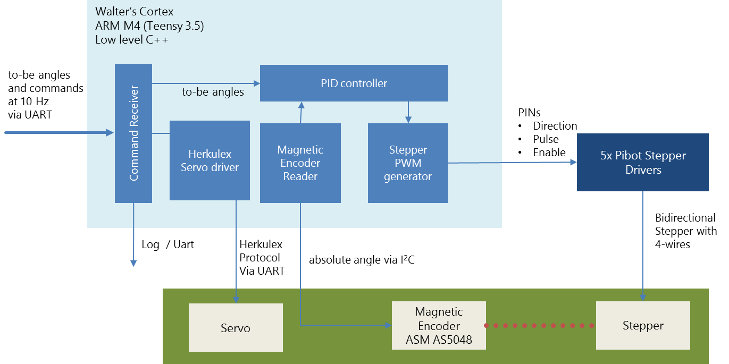

Figure 7‑1 Components of the Controller Board

The software runs on the basis of the Arduino library. This is a legacy, since I started with an 8-bit ATmega controller before I upgraded to an Arm processor (This happened when I realized, that controlling 5 steppers and encoders eats up much more computing power than I thought).

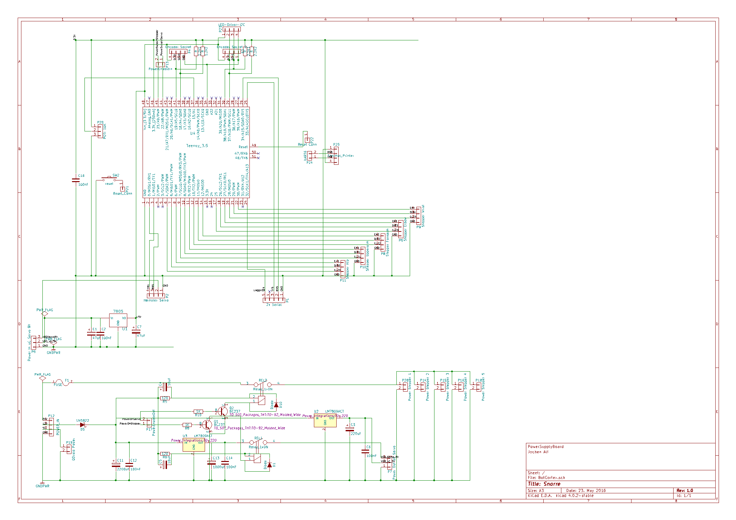

Figure 7‑2 Schematics of the controller board

The lower part of the layout contains a separate power supply for the servos, the steppers and C. The C gets 5V by a standard integrated voltage regulator (7805), the two servos are driven by a 7809 voltage regulator providing 2A (two HerkuleX servos required 1A at most). Additionally, there are two relays for a proper start-up procedure switching the 240W power supply for the steppers and the power supply for the servos. This has been necessary to avoid impulses to the motors inducing annoying ticks when power is switched on. So, after booting the Trajectory Board and switching on the Cortex Board, all steppers are disabled, then the steppers power supply is turned on, then the servos power supply is switched on. By that procedure, no ticks are happening during starting up.

On the top there is the Arm Cortex M4 controller receiving points to move to and controlling everything low level in a synchronous manner. As usual, tricky part was to provide a stable power supply for all components. I struggled a lot with pikes induced by the strong steppers, AS5048 rotary sensors that are very sensitive to voltage, and UARTs with not exact baud rates.

In the end, I made one board for the power supply providing 24V 10A for the steppers, 5V 4A for the ODroid and the ARM controller, and 9V 2A for Herkulex Servos. Servo’s and Stepper’s power supply are turned on by a relay controlled by the teensy that orchestrates the startup and teardown procedure. The second board on the right has almost no more than the Teensy controller and many sockets.

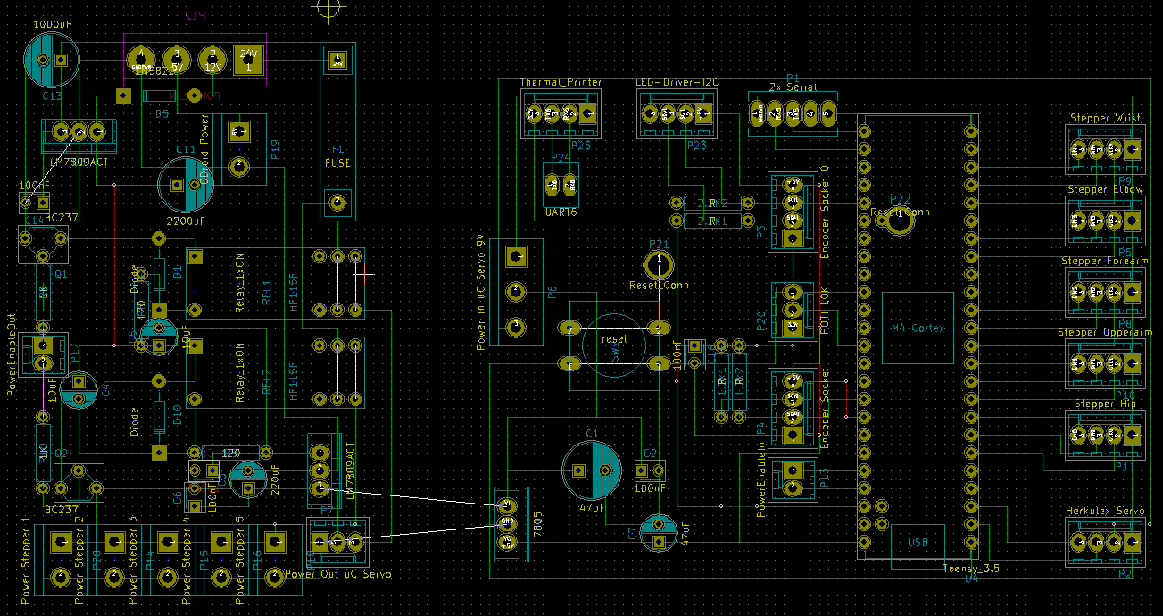

Figure 7‑3 Layout of the controller board  
The left part is providing power for uC & Servos, the right part is the ARM M4 controller

Putting all together looks like this:

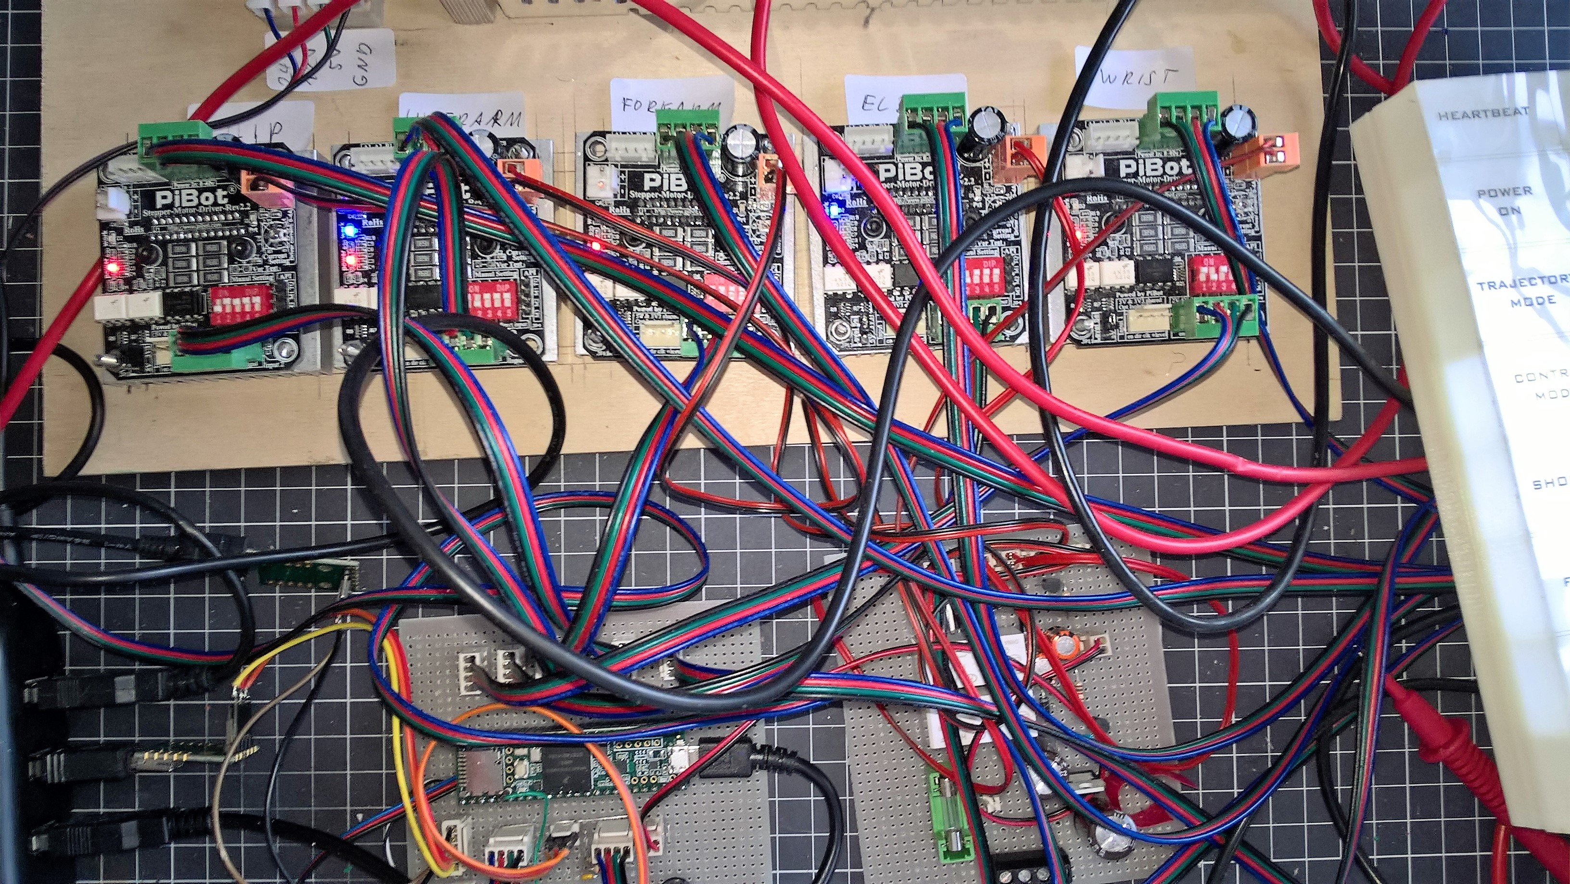

Figure 7‑4 My desk with 5 Pibot drivers, a Teensy 3.5 (on the left bottom side) and a power supply PCB  
Keeping the desk tidy and having a professional cable management is essential.

Controlling Steppers

While controlling robot servos is easy (everything is built in, even a PID controller, they only require a serial interface and a library), stepper motors are more difficult to control. While very tempting by providing high torque without a gearbox and a proper position even without encoders, they turned out to cost me many hours until they moved that smooth as expected.

First approach was the classical feed-back control system taking the encoder angle and the to-be angle of an actuator, giving that to PID controller, computing a correcting angle and giving that to the stepper motor. In the Arduino space, the standard library to control steppers is AccelStepper which can be used to implement that and leverage from the nice feature of smooth acceleration and deceleration.

This idea was bad. AccelStepper provides the method move(targetposition) that accelerates first and and decelerates afterwards until the motor stops exactly at the targetposition. This works fine for larger moves of several seconds. But in a closed loop, this accelerates and decelerates permanently producing vibrations and – depending on the speed – resonances. Speed was very limited not to mention a very bad sound.

The solution that finally worked was to compute the acceleration that is required in one sample of 10ms, and set this acceleration explicitly for the next sample:

|  |  |
| --- | --- |
| $$a=\frac{dv}{dt} with dt=10ms and dv=v_{end}- v_{start}+v_{encoder}$$ | (7‑1) |

*vencoder,* is the speed that is necessary to compensate the difference between encoder angle and to-be angle. It can be approximated by

|  |  |
| --- | --- |
| $v_{encoder}= \frac{ds}{dt}= \frac{error angle}{sample time}$. | (7‑2) |

Unfortunately, setting the acceleration requires a square root for computing the time until the next step (as done internally in AccelStepper)

|  |  |
| --- | --- |
| $s= \frac{1}{2}at^{2}\underset{⇒}{} t=\sqrt{\frac{2s}{a}}$ | (7‑3) |

This equation was the reason to decommission the previously used 8-bit Atmega and go to a 32-bit ARM processor with FPU which provides the square root computation in hardware.

The final closed-loop looks like this:

void stepperLoop () {

float dT = sampleTime(); // [ms], approx. 10ms  
float currentAngle = getEncoderAngle(); // encoder value in [°]  
  
// interpolate current trajectory to get current and next to-be angle  
float toBeAngle = movement.getCurrentAngle(millis());  
float nextToBeAngle = movement.getCurrentAngle(millis()+dT);

// get speed of current sample, next sample and error compared to encoder’s angle  
float currStepsPerSample = getMicroStepsByAngle(toBeAngle - lastToBeAngle);  
float nextStepsPerSample = getMicroStepsByAngle(nextToBeAngle - toBeAngle);  
float stepErrorPerSample = getMicroStepsByAngle(toBeAngle - currentAngle);

// implement PI controller. kP is 0.3-0.5, kI can be low (<0.1) depending on mechanics   
float Pout = kP * stepErrorPerSample;  
integral += stepErrorPerSample * dT;  
float Iout = kI * integral;  
float PIDoutput = Pout + Iout;  
float accelerationPerSample = PIDoutput;  
float distanceToNextSample = accelerationPerSample + currStepsPerSample;

// compute the acceleration for this sample   
float sampleAcc = ((currStepsPerSample-nextStepsPerSample+stepErrorPerSample)/dT;  
accel.setAcceleration(fabs(sampleAcc)); // do not accelerative faster than sampleAcc  
accel.move(distanceToNextSample); // move n steps

}

Bill of Material

Main components:

|  |  |  |
| --- | --- | --- |
|  | **What** | **From** |
| **1** | **3D printer (ABS)** | **Zortrax M200** |
| **5** | **5x Stepper Driver, TB 6600, 4A current** | **Pibot Stepper Driver 2.4** |
| **2** | **Robot Servos for gripper and hand** | **HerkuleX Servo DRS-101,** |
| **1** | **Power supply for steppers 24V, 10A,** | **www.omc-stepperonline.com,  S-250-24** |
| **1** | **Power supply for electronics and servos 12V 1A / 5V5A,** | **Meanwell RD35A** |
| **1** | **Walter’s Cortex: Arm M4 Cortex** | **Teensy 3.5** |
| **1** | **Walters Cerebellum: ARM A15, 2.0Ghz , running Linux** | **Hardkernel, Odroid XU4** |
| **1** | **Stepper motor wrist, Nema 17, 42x42x39, 0.40Nm** | **www.omc-stepperonline.com, 17HS-0404S,** |
| **1** | **Stepper motor elbow, Nema 17,** 42x42x25, 0.17Nm | [www.omc-stepperonline.com](http://www.omc-stepperonline.com)**,**  **17HS10-0704S** |
| **1** | **Stepper motor forearm, Nema 24, 60x60x57, 1.9Nm** | **Nanotec ST6018M2008. This one is expensive. Any other no longer than 68mm with similar torque works as well.** |
| **1** | **Stepper motor upperarm, Nema 24, 60x60x88, 3.1Nm** | **Global Biz, GB24H288-40-4A** |
| **1** | **Stepper motor hip, Nema 23, 57x57x56, 1.3Nm** | [www.omc-stepperonline.com](http://www.omc-stepperonline.com)  **23HM22-2804S** |

References

1. Controller board schematics   
   ./schematics/BotCortex.sch created with KiCad
2. Controller board layout  
   ./schematics/BotCortex.kicad-pcb

1. <https://de.wikipedia.org/wiki/Roll-Nick-Gier-Winkel#Berechnung_aus_Rotationsmatrix>